**EXP 9 CALCULATOR APP**

**AIM:**

To develop a basic Android calculator application using Button, TextView, and EditText controls for performing simple arithmetic operations — Addition, Subtraction, Multiplication, and Division.

**ALGORITHM:**

• Initialize the user interface with two EditText inputs, a TextView for the result, and four Button controls for operations.

• User enters two numbers in the EditText fields.

• Wait for the user to press an operation button (+, -, ×, ÷).

• Read both numbers from the EditText fields as strings.

• Check if both inputs are non-empty and convert them to numbers.

• Based on the button clicked, execute the corresponding arithmetic operation.

• If division is selected and the second number is zero, display an error message.

• Show the final result in the TextView or an error message if input is invalid.

**PROGRAM:**

**Activity_main.xml (UI Layout):**

<?xml version="1.0" encoding="utf-8"?>

<RelativeLayout xmlns:android="http://schemas.android.com/apk/res/android"

android:layout_width="match_parent"

android:layout_height="match_parent"

android:padding="20dp"

android:background="#ECEFF1">

<EditText

android:id="@+id/number1"

android:layout_width="match_parent"

android:layout_height="wrap_content"

android:hint="Enter First Number"

android:inputType="numberDecimal"

android:layout_marginBottom="15dp"

android:background="@android:drawable/editbox_background" />

<EditText

android:id="@+id/number2"

android:layout_width="match_parent"

android:layout_height="wrap_content"

android:hint="Enter Second Number"

android:inputType="numberDecimal"

android:layout_below="@id/number1"

android:layout_marginBottom="15dp"

android:background="@android:drawable/editbox_background" />

<TextView

android:id="@+id/result"

android:layout_width="match_parent"

android:layout_height="wrap_content"

android:text="Result will appear here"

android:textSize="18sp"

android:textColor="#000"

android:layout_below="@id/number2"

android:layout_marginBottom="20dp"

android:padding="10dp"

android:background="#CFD8DC" />

<LinearLayout

android:layout_width="match_parent"

android:layout_height="wrap_content"

android:orientation="horizontal"

android:layout_below="@id/result"

android:gravity="center"

android:weightSum="4">

<Button

android:id="@+id/add"

android:layout_width="0dp"

android:layout_weight="1"

android:layout_height="wrap_content"

android:text="+" />

<Button

android:id="@+id/subtract"

android:layout_width="0dp"

android:layout_weight="1"

android:layout_height="wrap_content"

android:text="-" />

<Button

android:id="@+id/multiply"

android:layout_width="0dp"

android:layout_weight="1"

android:layout_height="wrap_content"

android:text="×" />

<Button

android:id="@+id/divide"

android:layout_width="0dp"

android:layout_weight="1"

android:layout_height="wrap_content"

android:text="÷" />

</LinearLayout>

</RelativeLayout>

**MainActivity.java** **(Java Code):**

package com.example.calculator;

import androidx.appcompat.app.AppCompatActivity;

import android.os.Bundle;

import android.view.View;

import android.widget.Button;

import android.widget.EditText;

import android.widget.TextView;

public class MainActivity extends AppCompatActivity {

EditText number1, number2;

TextView result;

Button add, subtract, multiply, divide;

@Override

protected void onCreate(Bundle savedInstanceState) {

super.onCreate(savedInstanceState);

setContentView(R.layout.activity_main);

number1 = findViewById(R.id.number1);

number2 = findViewById(R.id.number2);

result = findViewById(R.id.result);

add = findViewById(R.id.add);

subtract = findViewById(R.id.subtract);

multiply = findViewById(R.id.multiply);

divide = findViewById(R.id.divide);

add.setOnClickListener(view -> calculate('+'));

subtract.setOnClickListener(view -> calculate('-'));

multiply.setOnClickListener(view -> calculate('*'));

divide.setOnClickListener(view -> calculate('/'));

}

private void calculate(char operator) {

String num1 = number1.getText().toString().trim();

String num2 = number2.getText().toString().trim();

if (num1.isEmpty() || num2.isEmpty()) {

result.setText("Please enter both numbers.");

return;

}

try {

double a = Double.parseDouble(num1);

double b = Double.parseDouble(num2);

double res = 0;

switch (operator) {

case '+':

res = a + b;

break;

case '-':

res = a - b;

break;

case '*':

res = a * b;

break;

case '/':

if (b == 0) {

result.setText("Error: Division by zero!");

return;

}

res = a / b;

break;

}

result.setText("Result: " + res);

} catch (NumberFormatException e) {

result.setText("Invalid Input!");

}

}

}

**OUTPUT:**

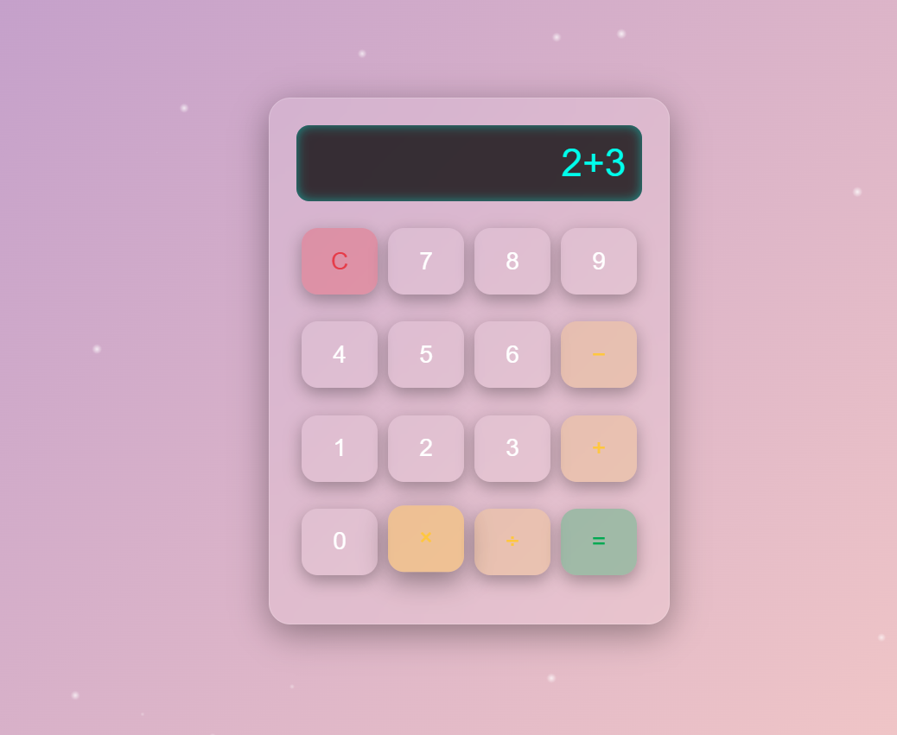

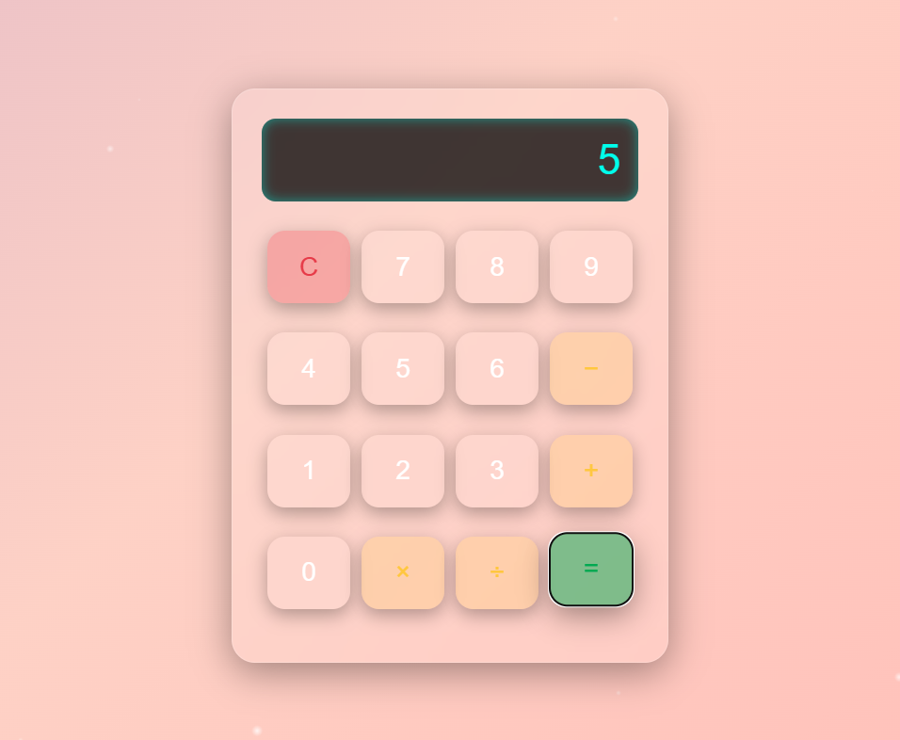

**RESULT:** Thus the calculator app is developed.